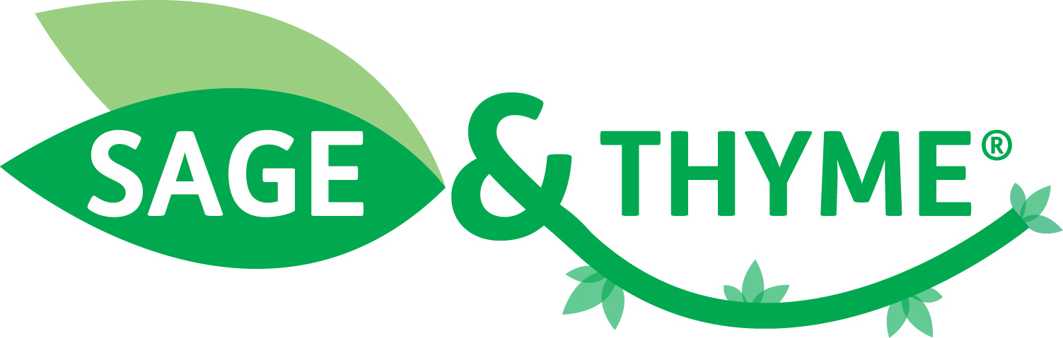 | 

SAGE & THYME® UK 2014 Conference
Wednesday 19 November 2014, 9:30am - 4:15pm
Education and Research Centre, Wythenshawe Hospital, Manchester

Who should attend?

- SAGE & THYME foundation level workshop facilitators (both recently trained and experienced) and managers overseeing the training in their organisation.

- People interested in running SAGE & THYME workshops in their organisation.

What’s in the programme?

A mixture of presentations and parallel workshops covering the following:

- SAGE & THYME update
- From early adoption to large scale roll-out across the PallE8 network - Katherine Hopkins, Royal Free London NHS Foundation Trust
- Boots pharmacists working with patients - David Walker, Boots UK Ltd
- Incorporating SAGE & THYME in mandatory training - Joanne Lane, Aneurin Bevan University Health Board
- Princess Alice Education Centre Experience - Jane Berg/Gill Thomas, Princess Alice Hospice
- Keeping on top of the evidence – Mike Connolly, SAGE & THYME Team
- Finding out what patients think – how do we do it? – Debra de Silva, Evidence Centre
- Using SAGE & THYME with patients and relatives – stories shared

What did people think of last year’s conference?

“Excellent so well organised and well thought through. Very professional facilitators/day.”

“Really was worthwhile day - more than happy to have travelled from the North of Scotland. I was a champion of SAGE & THYME before - but now I am energised and will go straight to my chief executive at board for money and commitment to listen to patients.”

“Inspirational and motivational: great to hear what is going on elsewhere.”

How much will it cost and how do I book a place?

The cost will be £65 per person. If you would like to attend, please complete and return the attached booking form to arrive no later than 31 October 2014. Places will be allocated on a first-come-first-served basis.

Contact us

If you have any questions, please contact: sageandthyme@uhsm.nhs.uk; or ring 0161 291 4210.

SAGE & THYME® UK 2014 Conference Booking Form
Wed 19 November 2014, Wythenshawe Hospital, Manchester

Surname:

First Name:

Job Title:

Department:

Organisation:

Address:

Email Address:

Contact No:

Please state if you are a SAGE & THYME facilitator and also which licence(s) you come under (if you are not a facilitator please state your reason for attending):
Invoice Address:

Purchase order (PO) number (£65 per delegate)
Please check with your finance department and state if your organisation does not need to issue a PO number
Dietary requirements:

Would you be happy to speak for 5 min in a parallel session in the afternoon, about an experience you had where you used the SAGE & THYME model with a patient/relative/carer? | Yes / No / Not applicable

Please complete and return via email to sageandthyme@uhsm.nhs.uk by 31 October 2014.

